Terraform Task-3
1. Execute the script shown in the video.
1. First understand what a variable is
Suppose Terraform code has: resource "local_file" "pet" {
filename = "pets.txt"
content = "We love pets" }
Here pets.txt is hard-coded.
If tomorrow you want: /tmp/pets.txt
you have to modify main.tf. Instead, we create a variable:
variable "filename" {
default = "pets.txt" }
Then: resource "local_file" "pet" {
filename = var.filename
content = "We love pets"}
Now the value can be changed without modifying the resource.
Basic syntax
variable "filename" {
default = "pets.txt"
type = string
description = "Path of the file to create"}
And use it as: var.filename
Step1:Create a folder
Terraform-provider
Step 2: Create two files
main.tf
variables.tf
Step 3: Add resources in main.tf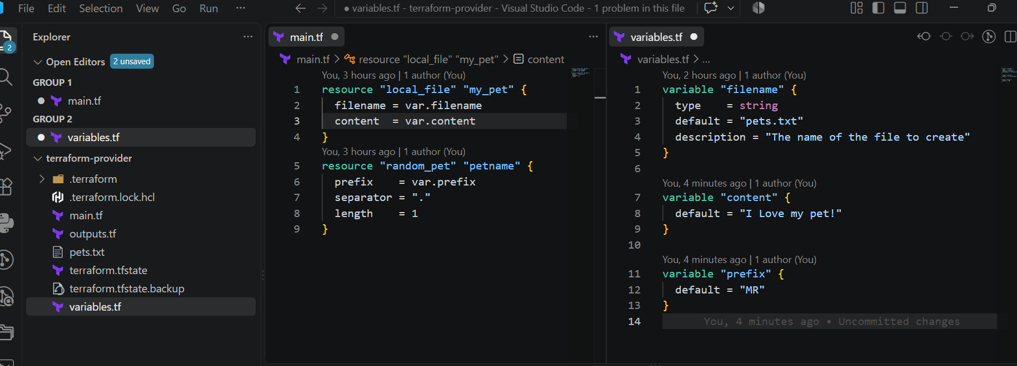
Step 4: Add variables in variables.tf
Step 5: Initialize Terraform
terraform init
Step 6: Validate configuration
terraform validate
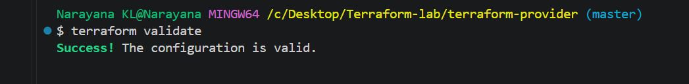
Step 7: Check execution plan
terraform plan
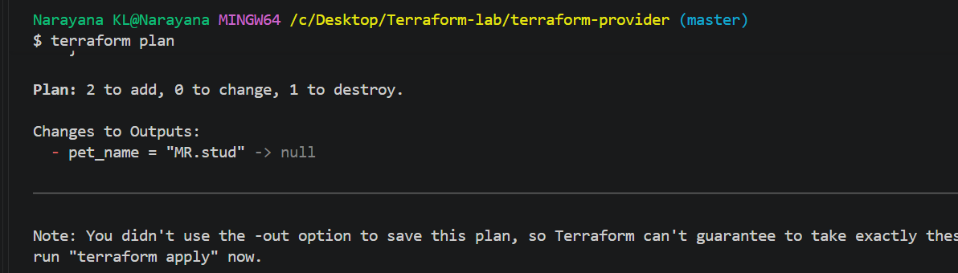
Step 8: Create resources
terraform apply
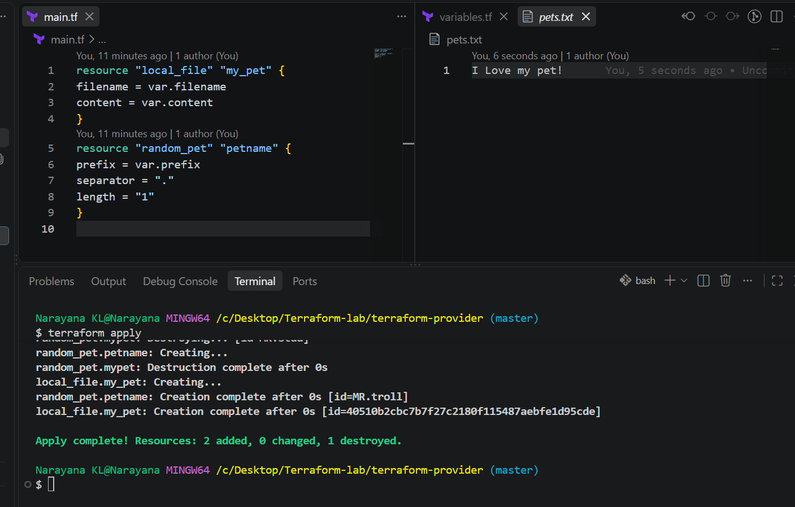
Interactive Variables — Hands-on
Step 1: Create variables.tf
variable "filename" {
}
variable "content" {
}
variable "prefix" {
}
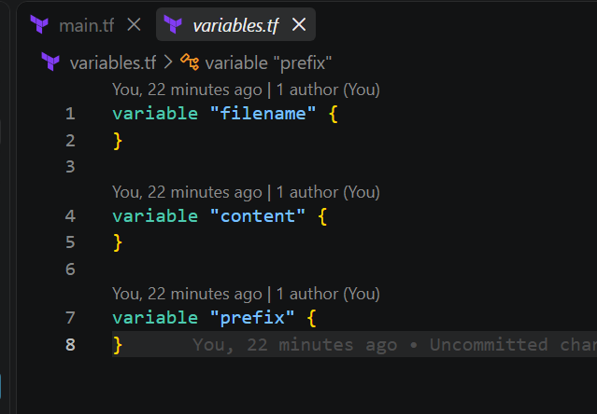
Step 2: Create main.tf
resource "local_file" "my_pet" {
filename = var.filename
content = var.content }
resource "random_pet" "my_pet" {
prefix = var.prefix
length = 1
separator = "-" }
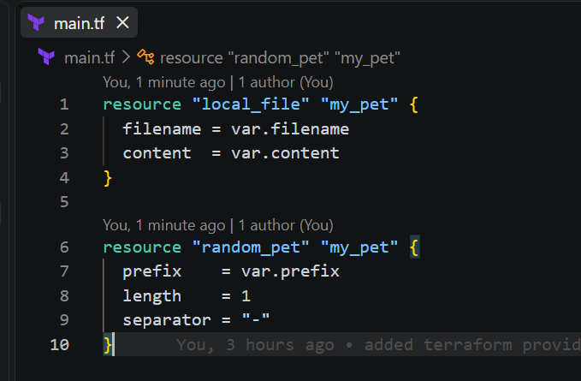
Step 3: Initialize
terraform init
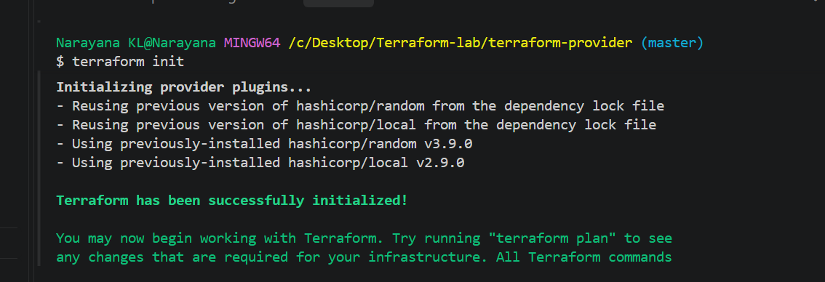
Step 4: Validate
terraform validate
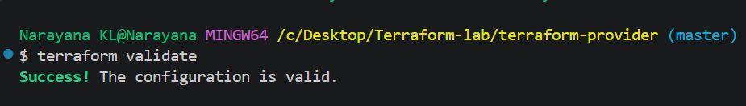
Step 5: Apply
terraform apply
Terraform will ask: var.filename
Enter a value: var.content
Enter a value: var.prefix
Enter a value:
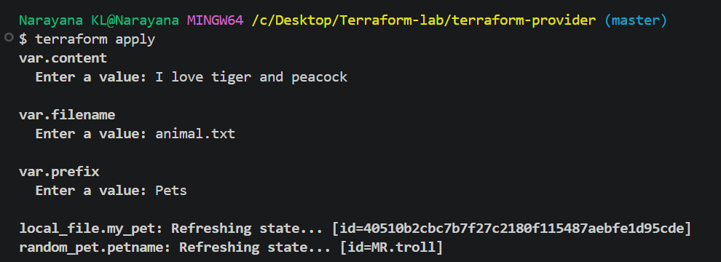
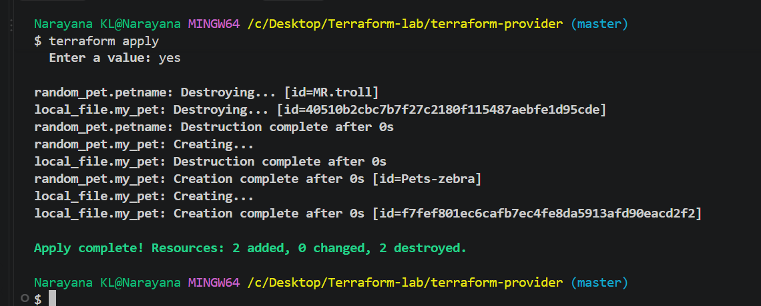
Enter your values and Terraform will create the resources.
Command-Line Flags — Terraform Variables
Step 1: variables.tf
variable "filename" {
}
variable "content" {
}
variable "prefix" {
}
Step 2: main.tf
resource "local_file" "my_pet" {
filename = var.filename
content = var.content
}
resource "random_pet" "my_pet" {
prefix = var.prefix
length = 1
separator = "-"
}
Step 3: Initialize
terraform init
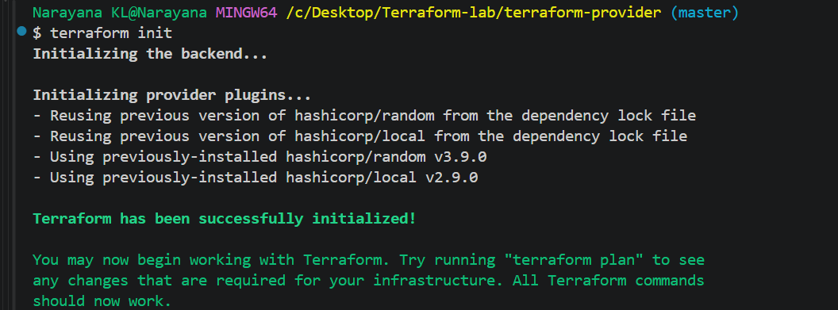
Step 4: Validate
terraform validate
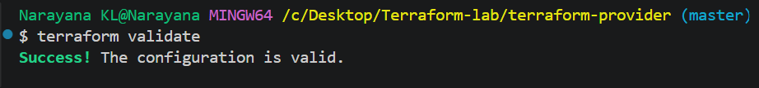
Step 5: Pass values using command-line flags
terraform apply -var="filename=animals.txt" -var="content=I love elephants!" -
var="prefix=DEV"
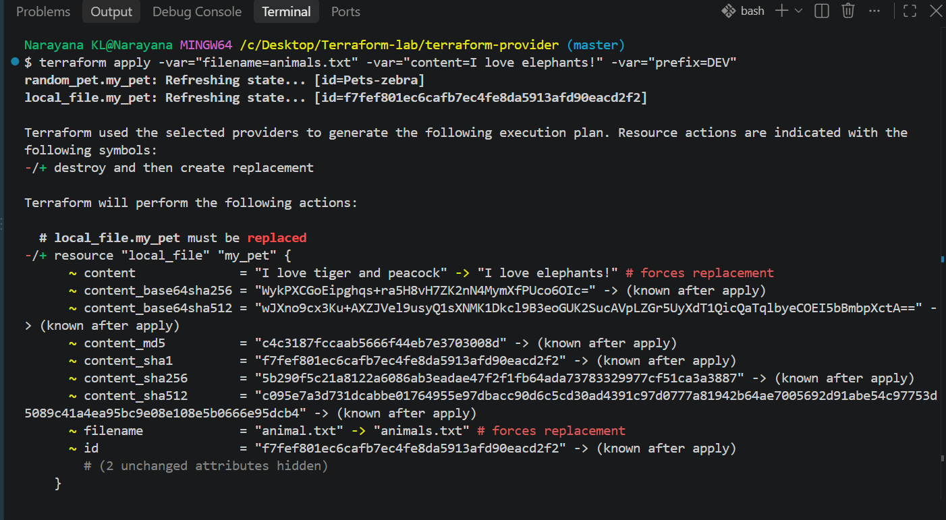
Step 6: Verify
Terraform creates: animals.txt
with: I love elephants!
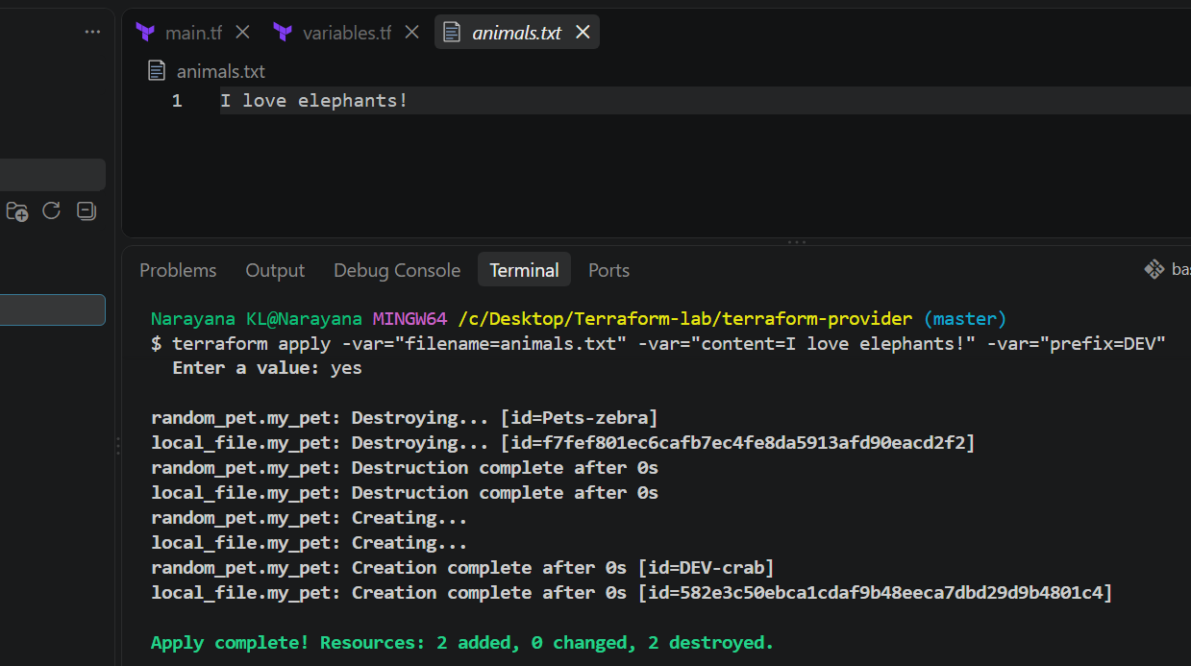
Key point: -var allows you to provide variable values directly from the command line.
Environment Variables
Your notes have a small typo: Terraform environment variables must start with
TF_VAR_, not TF_val_.
Step 1: variables.tf
variable "filename" {
}
variable "content" {
}
variable "prefix" {
}
Step 2: main.tf
resource "local_file" "my_pet" {
filename = var.filename
content = var.content
}
resource "random_pet" "my_pet" {
prefix = var.prefix
length = 1
separator = "-"
}
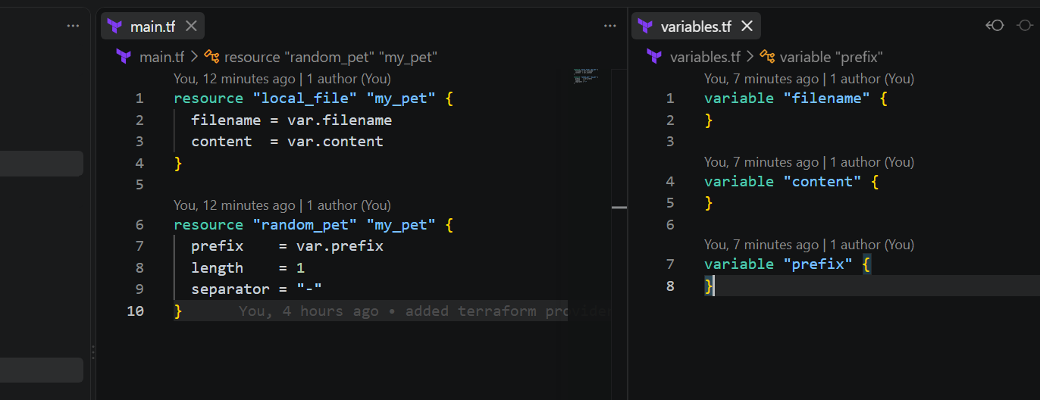
Step 3: Set variables in gitbash
export TF_VAR_filename="world.txt"
export TF_VAR_content="lorpa"
export TF_VAR_prefix="miss"
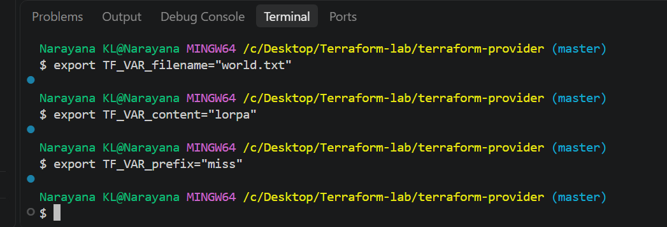
Step 4: Verify
echo $TF_VAR_filename
echo $TF_VAR_content
echo $TF_VAR_prefix
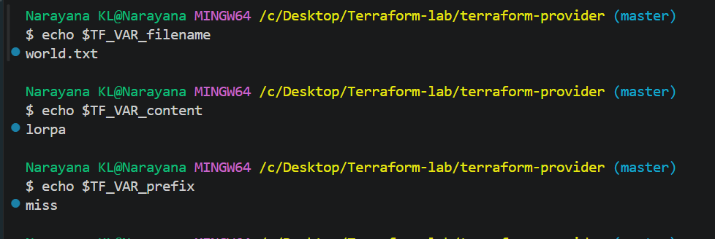
Step 5: Apply
terraform apply
Terraform automatically takes: TF_VAR_filename → var.filename
TF_VAR_content → var.content
TF_VAR_prefix → var.prefix
To change the values
export TF_VAR_filename="world.txt"
export TF_VAR_content="lorpa"
export TF_VAR_prefix="miss"
Then: terraform apply
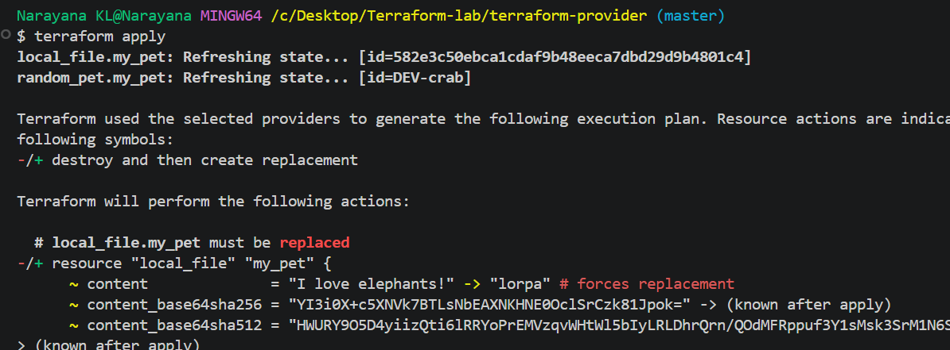
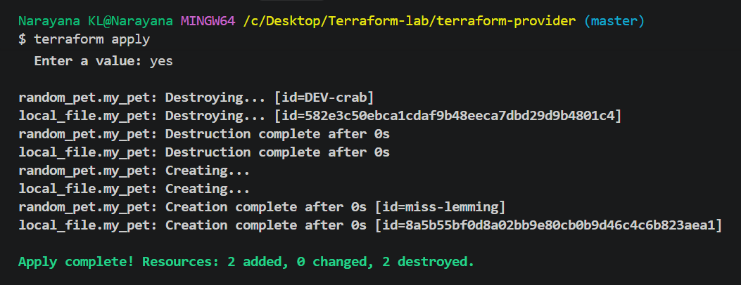
Variable Precedence
Use case: If you define a default value in variables.tf and also provide a TF_VAR_...
environment variable, Terraform will use the environment variable value because it
has higher precedence than the variable's default.
To prove the environment variable is overriding default
Terraform Variable Precedence
1. Environment variable — TF_VAR_name
2. terraform.tfvars
3. *.auto.tfvars
4. -var / -var-file
Step 1 — variables.tf
Create/update variables.tf:
variable "filename" {
default = "pets.txt"
}
variable "content" {
default = "I love cats"
}
variable "prefix" {
default = "DEV"
}
Here, you have defined variables + default values.
Step 2 — main.tf
resource "local_file" "my_pet" {
filename = var.filename
content = var.content
}
resource "random_pet" "my_pet" {
prefix = var.prefix
length = 1
separator = "-"
}
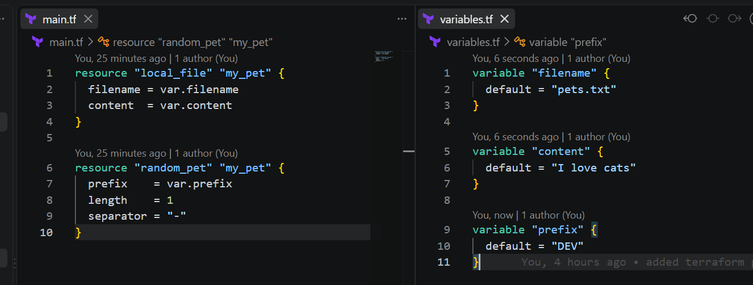
Step 3 — Open VS Code Terminal
Go to: Terminal → New Terminal
You should see: Narayana KL@Narayana MINGW64 /c/Desktop/Terraform-lab/terraform-provider (master)
Step 4 — Pass different values using Environment Variables
export TF_VAR_filename="world.txt1"
export TF_VAR_content="welcome to pets world"
export TF_VAR_prefix="king"
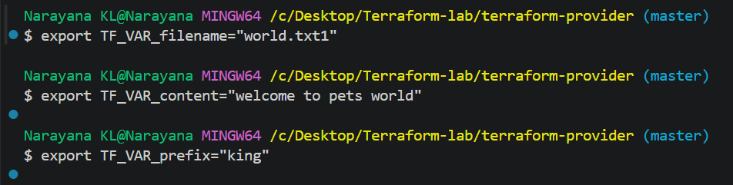
Step 5 — Verify Environment Variables
echo $TF_VAR_filename
echo $TF_VAR_content
echo $TF_VAR_prefix
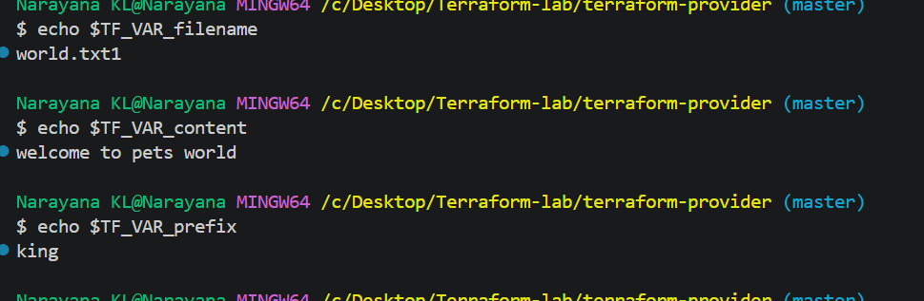
Step 6 — Run Terraform
terraform apply
Terraform will use the environment variable values, not the defaults from
variables.tf.
So: variables.tf Environment Variable
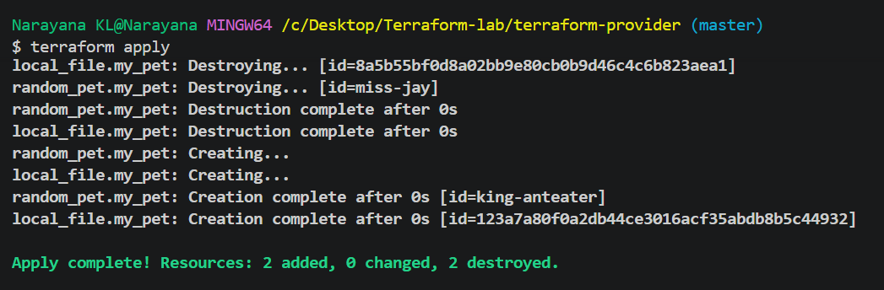------------------------------------------------
pets.txt → world.txt1
I love cats → welcome to pets world
DEV → kings
Step 7 — Change the Environment Variable
For example: export TF_VAR_filename="world.txt1"
export TF_VAR_content="welcome to pets world"
export TF_VAR_prefix="king"
Then: terraform apply
Terraform will detect the changes and update the resources.

Key point: default in variables.tf is the fallback value. TF_VAR_* environment
variables override the default.
Terraform Resource Dependency
Step 1: Open your Terraform folder in VS Code
Open your existing folder: Narayana KL@Narayana MINGW64 /c/Desktop/Terraform-lab/terraform-provider (master)
Step 2: Create main.tf
Use this: resource "random_pet" "my_pet" {
prefix = "DEV"
length = 1
}
resource "local_file" "my_file" {
filename = "pet.txt"
content = "This file depends on the pet resource"
depends_on = [random_pet.my_pet]
}
Here: random_pet.my_pet.id
is the resource reference.
It means: Get the id value from random_pet.my_pet and put it inside pet.txt.
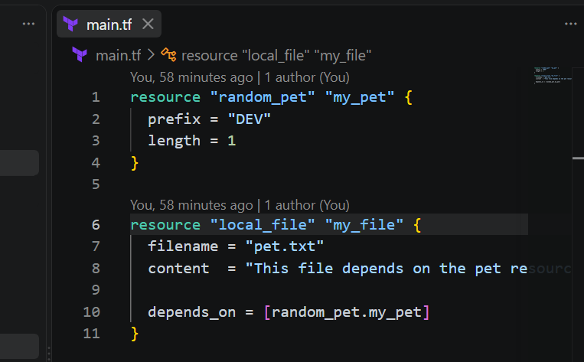
Step 3: Initialize Terraform
In VS Code terminal: terraform init
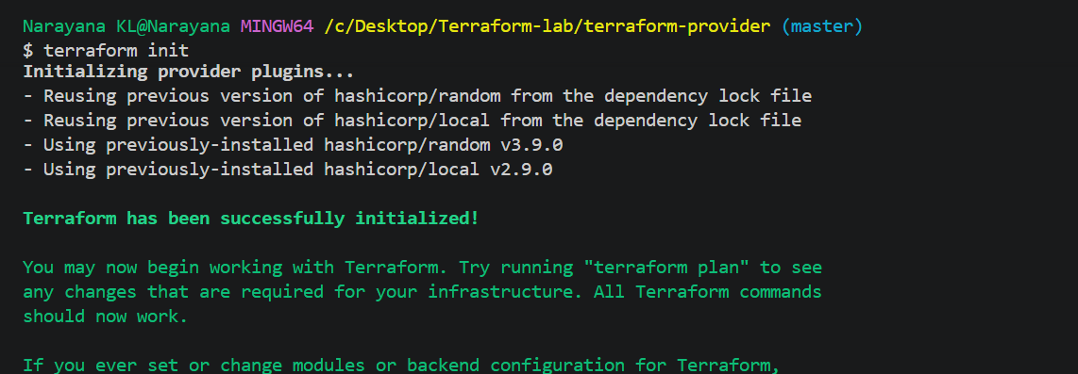
Step 4: Check the plan
terraform plan
Terraform understands that:
random_pet → local_file
because local_file references random_pet.
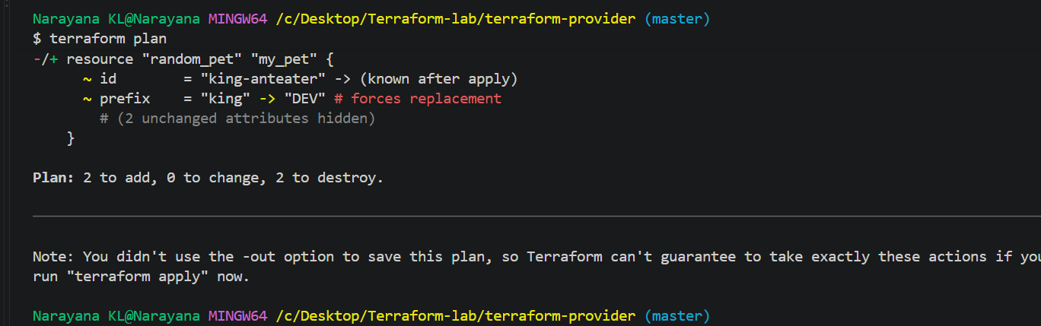
Step 5: Apply
terraform apply yes
Step 6: Check the generated file
You will see: pet.txt
DEV-ox
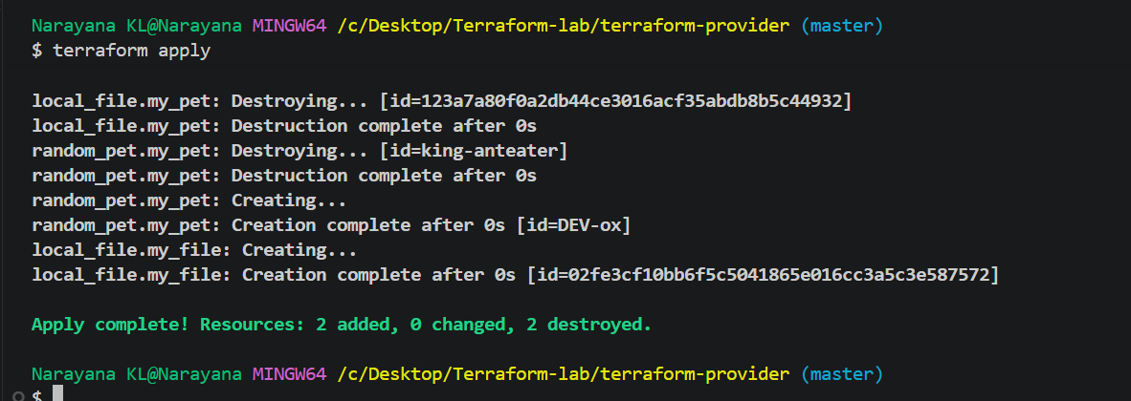
The value comes from: random_pet.my_pet.id
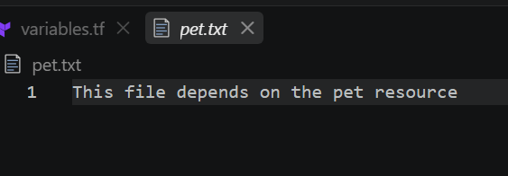
Step 7: Understand the dependency
Terraform creates: random_pet.my_pet
↓
↓ reference
↓
local_file.my_file
So Terraform automatically knows: Create random_pet first, then create local_file.
This is called an implicit dependency.
Step 8: Try Explicit Dependency
Change main.tf to: Now there is no resource reference in content.
But: depends_on = [random_pet.my_pet]
manually tells Terraform: Create random_pet.my_pet before local_file.my_file.
Step 9: Apply again
terraform plan
terraform apply
Terraform Output Variables
An output variable is used to display or expose a value after Terraform creates a
resource.
For example, after creating a random pet, we can display its name.
Step 1: Keep your main.tf
resource "random_pet" "my_pet" {
prefix = "DEV"
length = 1
}
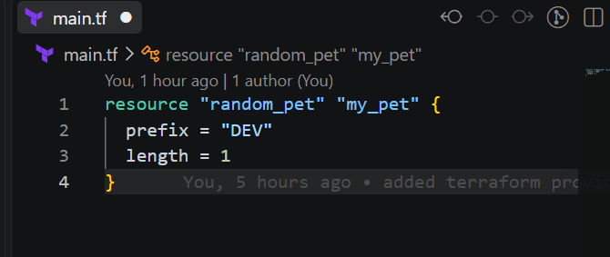
Step 2: Create outputs.tf
output "pet_name" {
value = random_pet.my_pet.id
}
Here: random_pet.my_pet.id
is the resource reference.
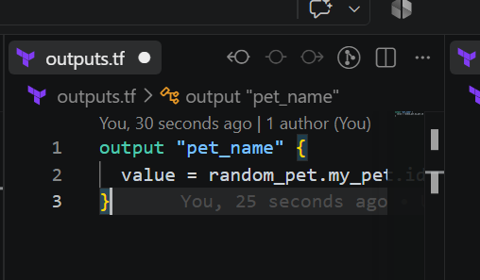
Step 3: Run Terraform
terraform init
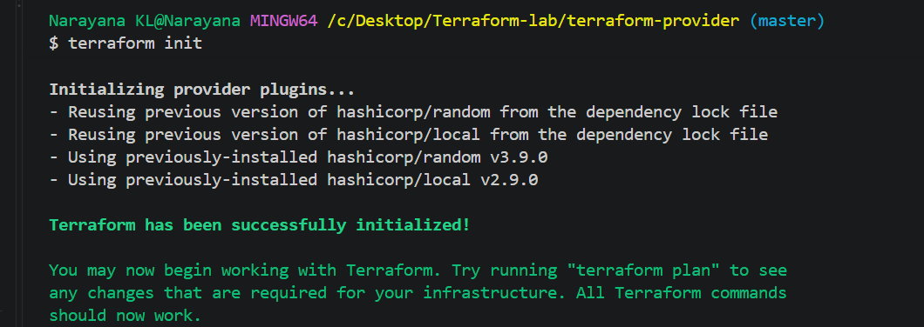
terraform apply
Enter: yes
Step 4: Check the output
You should see something like:
Outputs: pet_name = "DEV-ox"
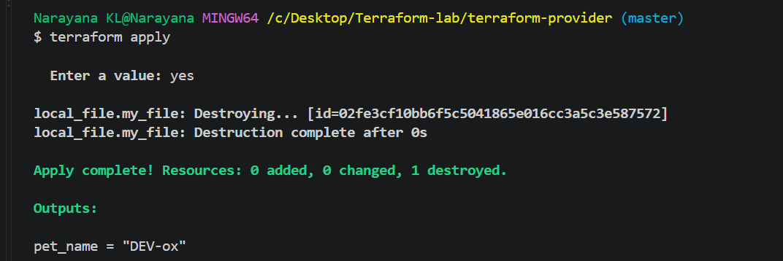
Step 5: Display output anytime
After terraform apply, run: terraform output
Or only the specific output:
terraform output pet_name
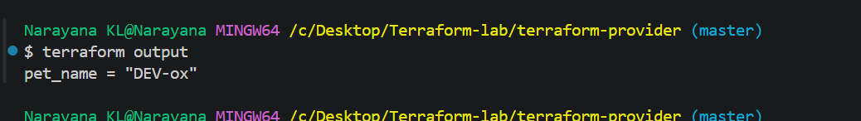
Simple interview definition
Output variable is used to display or expose values generated by Terraform
resources.
Flow:
Resource
↓
random_pet.my_pet.id
↓
output "pet_name"
↓
terraform output
Important: output is different from an input variable.
• variable → gives values to Terraform
• output → gives values from Terraform
3. Integrate Terraform in Jenkins using the Terraform plugin.
1. Jenkins → Manage Jenkins → Plugins
o Search Terraform
o Install Terraform Plugin.
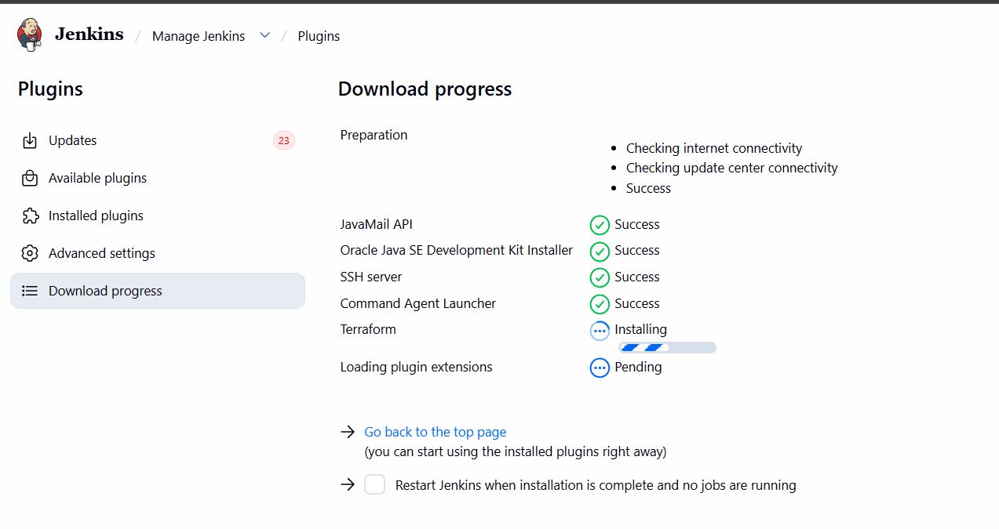
2. Manage Jenkins → Tools
o Find Terraform installations
o Click Add Terraform
o Name: terraform
o Select Terraform version / auto-install
o Save
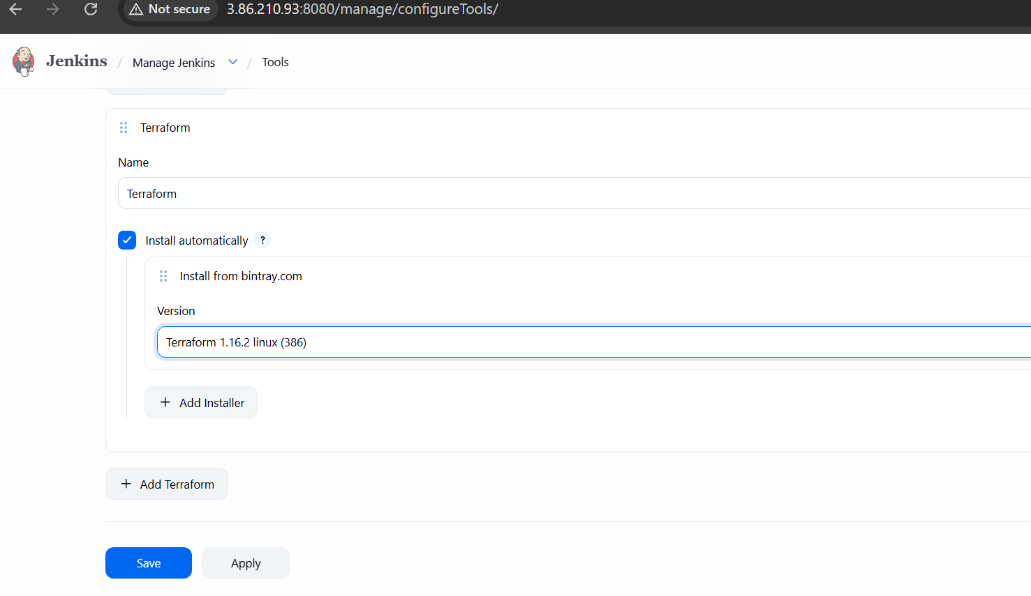
3. Create Jenkins Pipeline
o New Item → Terraform-jenkins-pipeline
o Select Pipeline
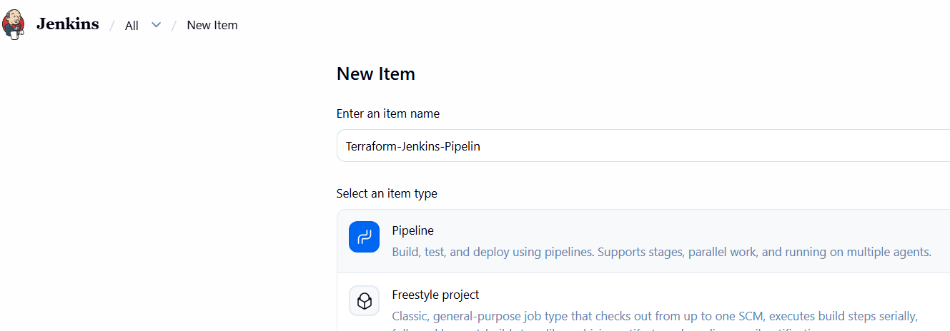
4. Add this Jenkinsfile:
pipeline {
agent any
environment {
TF_HOME = tool(
name: 'terraform',
type: 'org.jenkinsci.plugins.terraform.TerraformInstallation'
)
PATH = "${TF_HOME}:${env.PATH}"
}
stages {
stage('Checkout') {
steps {
checkout scm
}
}
stage('Terraform Init') {
steps {
sh 'terraform init'
}
}
stage('Terraform Validate') {
steps {
sh 'terraform validate'
}
}
stage('Terraform Plan') {
steps {
sh 'terraform plan'
}
}
}
}
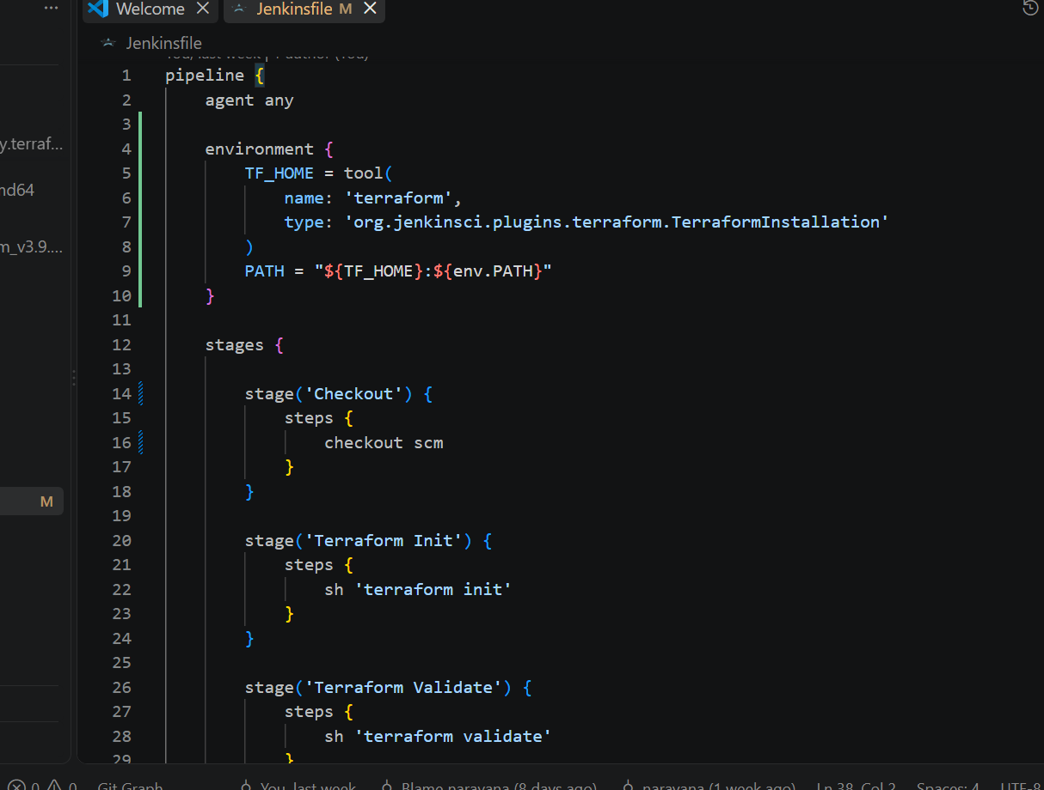
5. Connect GitHub
o Pipeline → Pipeline script from SCM
o SCM: Git
o Add your GitHub repository
o Branch: main
o Script Path: Jenkinsfile
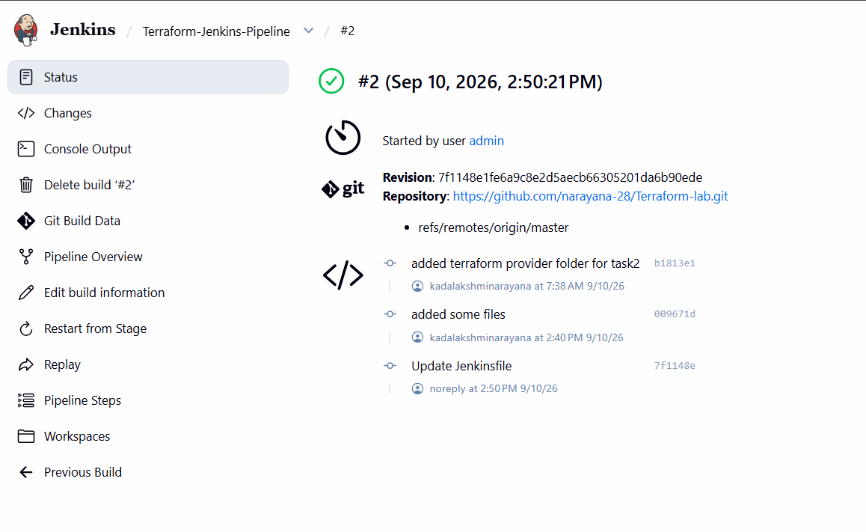
6. Build Now → check Console Output.
Flow
GitHub → Jenkins → Terraform Plugin → Terraform → AWS
Jenkins Terraform Plugin and Terraform AWS Provider are different things. terraform
init downloads the AWS provider automatically.
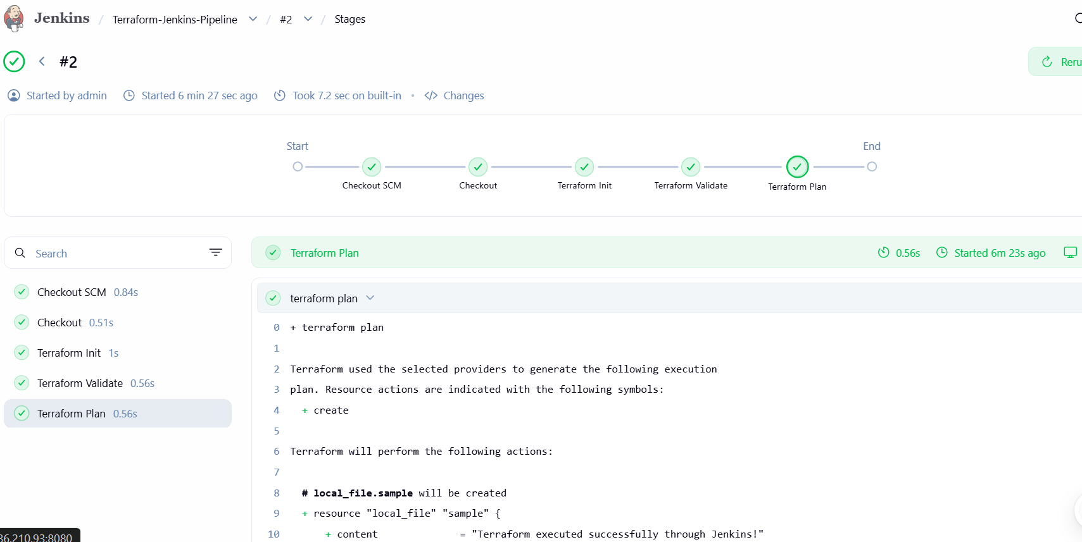
4. Create one Jenkins job using Maven Project for the code below with two stages:
• Stage 1:Git clone
• Stage 2:Maven CompilationCode:https://github.com/betawins/java-Working-
app.git
1. Create Jenkins Job
Jenkins → New Item
Name: java-working-app
Select:
Maven project
Click OK. Jenkins supports a dedicated Maven project type.
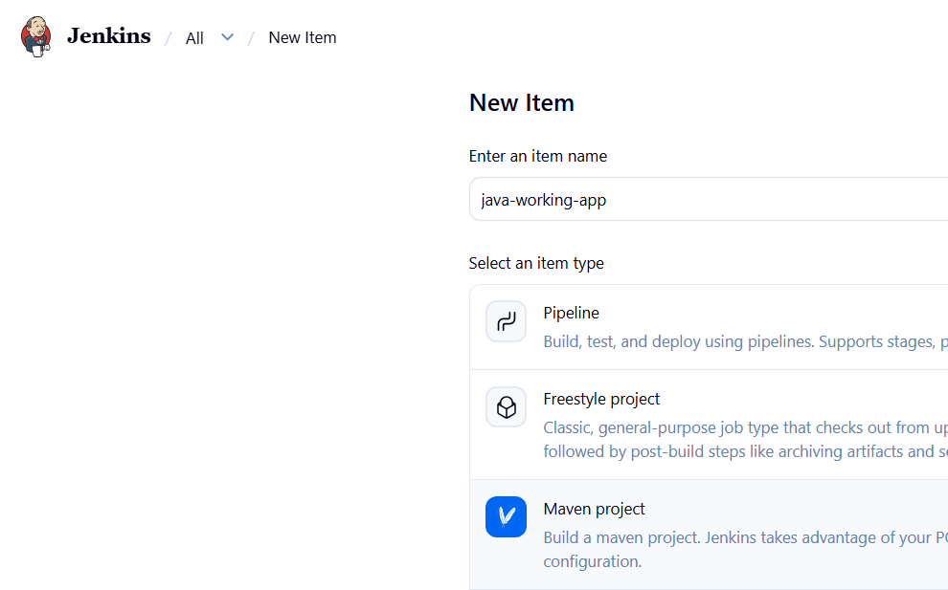
2. Stage 1 — Git Clone
In Source Code Management:
Select: Git
Repository URL: https://github.com/betawins/java-Working-app.git
Branch:
*/main
If the repository is public, you don't need credentials.
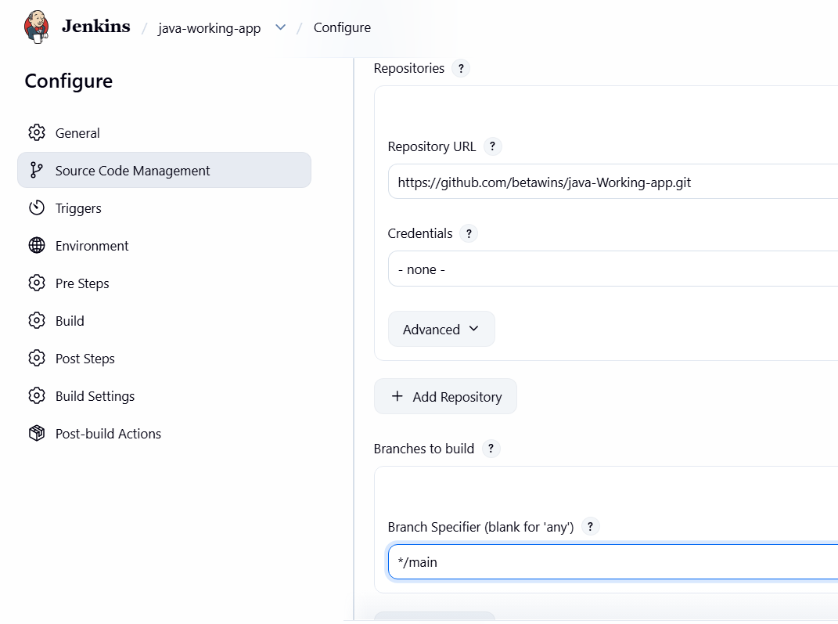
3. Stage 2 — Maven Compilation
Find Build section.
In Goals and options, enter:
clean compile
That's it. Maven will compile the Java project using its pom.xml.
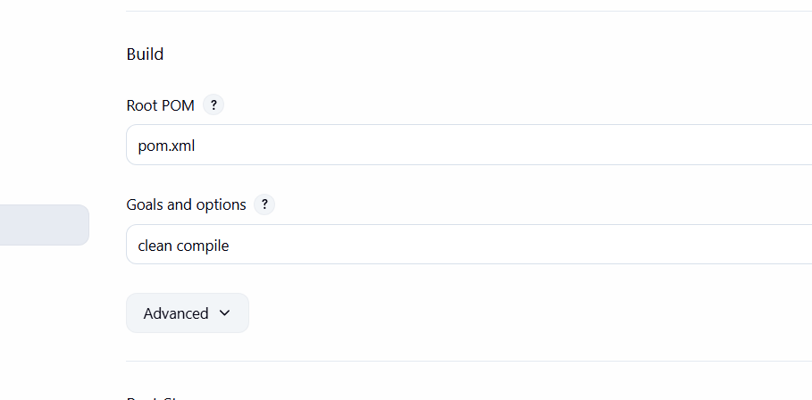
4. Save and Build
Click:
Save → Build Now
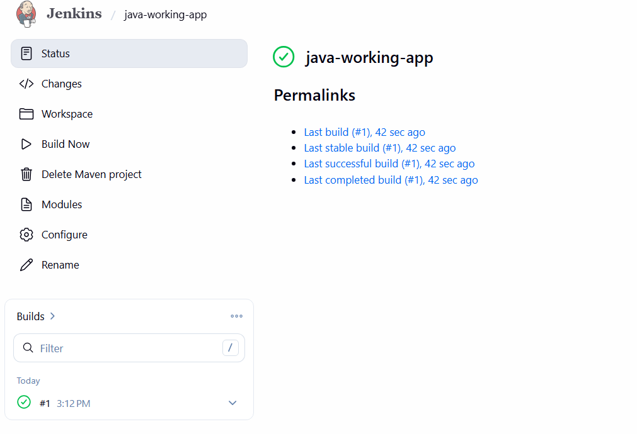
Then:
Build #1 → Console Output
You should see:
Git clone
↓
Downloading Maven dependencies
↓
mvn clean compile
↓
BUILD SUCCESS
So your two stages are effectively:
Stage 1: Git Clone
↓
Stage 2: Maven Compilation
↓
SUCCESS
For this particular requirement, you do not need a Jenkinsfile because you're
specifically creating a Maven Project job.
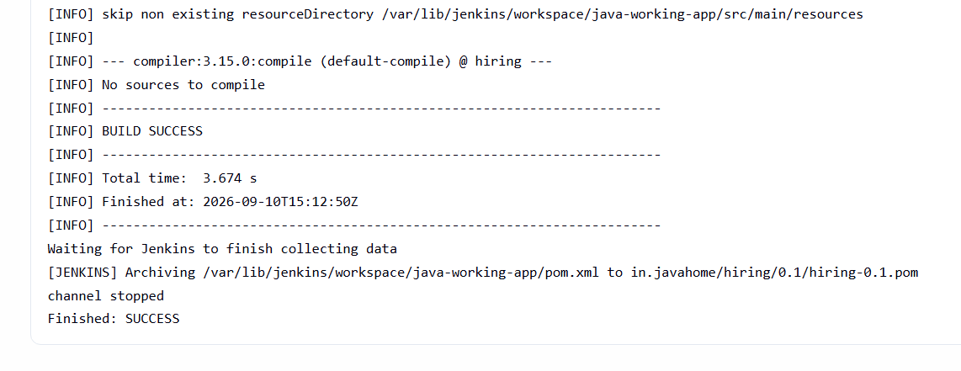
5. Use the same code and create a parameterized job in Jenkins with:
• Stage 1:Git clone
• Stage 2:Maven CompilationCode:https://github.com/betawins/java-Working-
app.git
Jenkins job will have:
1. Stage 1 — Git Clone
2. Stage 2 — Maven Compilation
Git repository: https://github.com/betawins/java-Working-app.git
Step 1: Create Jenkins Job
Go to Jenkins: Dashboard → New Item
Enter: java-working-app-parameterized
Select: Pipeline
Click OK.
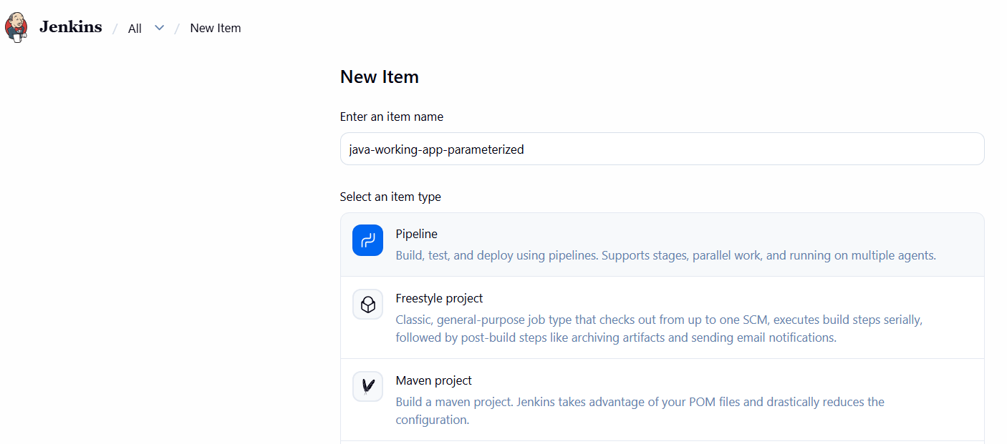
Step 2: Make it Parameterized
In the job: Configure → General
Check: This project is parameterized
Click: Add Parameter → Choice Parameter
Use: Name: BRANCH
Choices: Main
master
Description: Select the Git branch to build
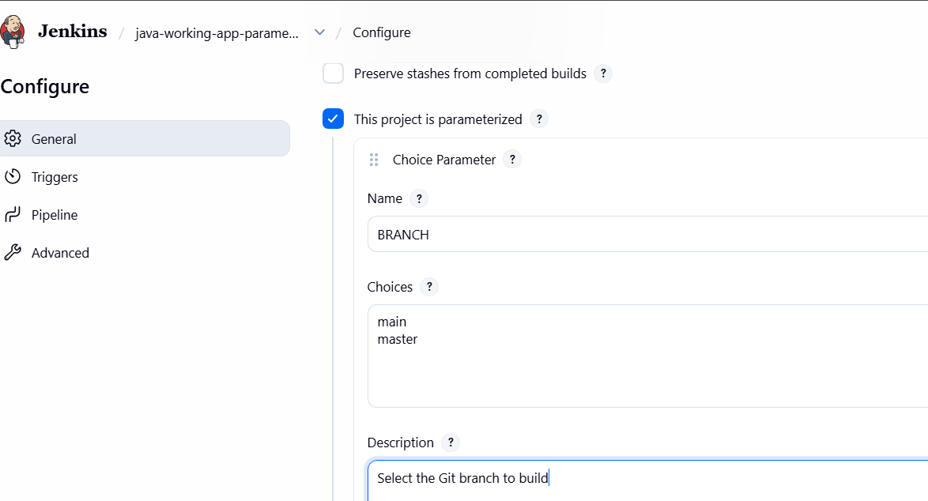
Step 3: Add Pipeline
Go to: Pipeline → Definition
Select:Pipeline script
Paste this:
pipeline {
agent any
parameters {
choice(
name: 'BRANCH',
choices: ['main', 'master'],
description: 'Select the Git branch to build'
)
}
stages {
stage('Git Clone') {
steps {
git branch: "${params.BRANCH}",
url: 'https://github.com/betawins/java-Working-app.git'
}
}
stage('Maven Compilation') {
steps {
sh 'mvn clean compile'
}
}
}
}
Click:
Save
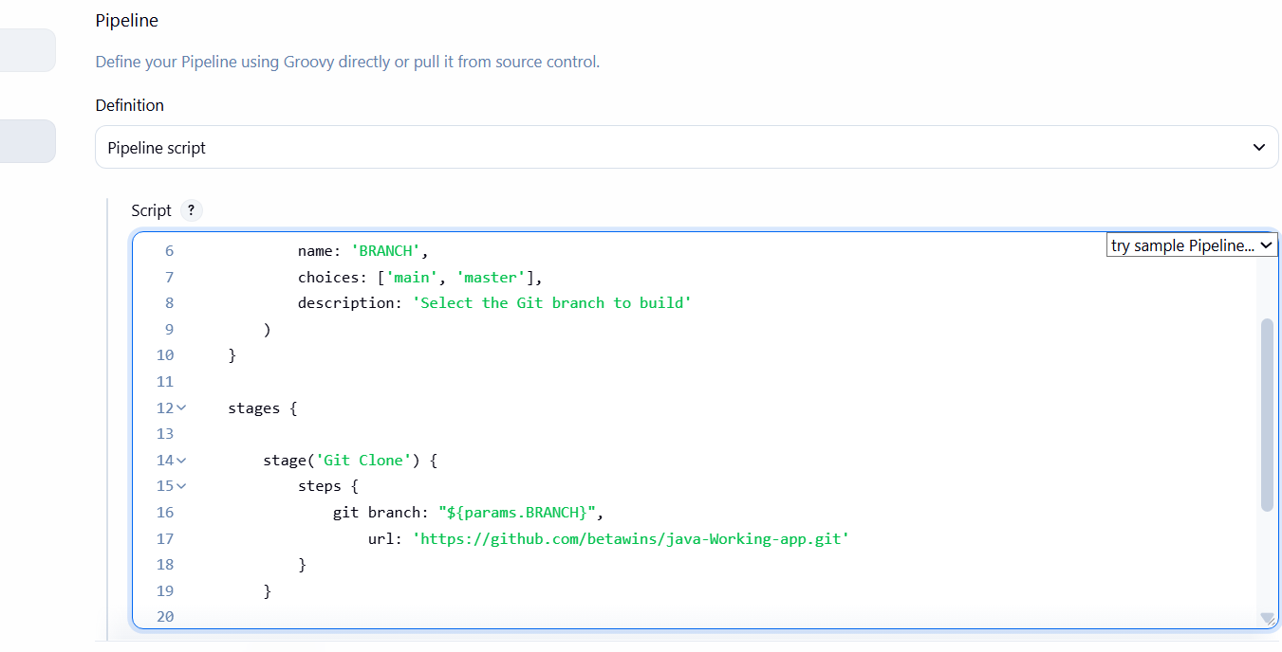
Step 4: Run the Job
Click: Build with Parameters
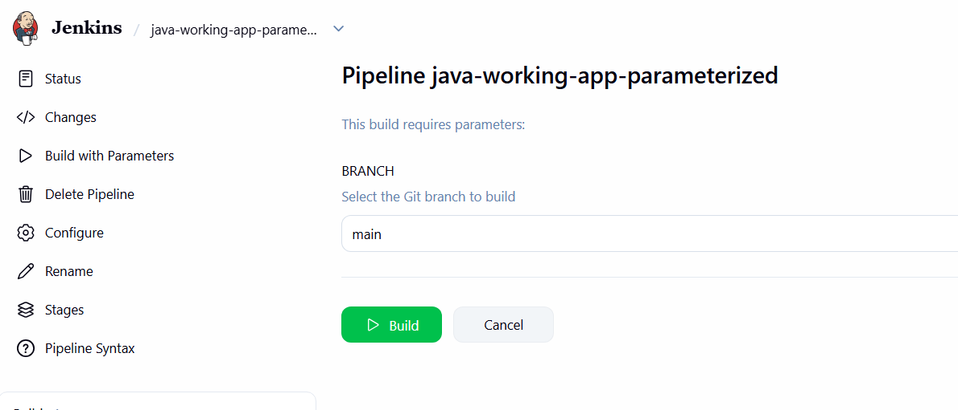
You will see: BRANCH [main ▼]
Select:main
Click: Build
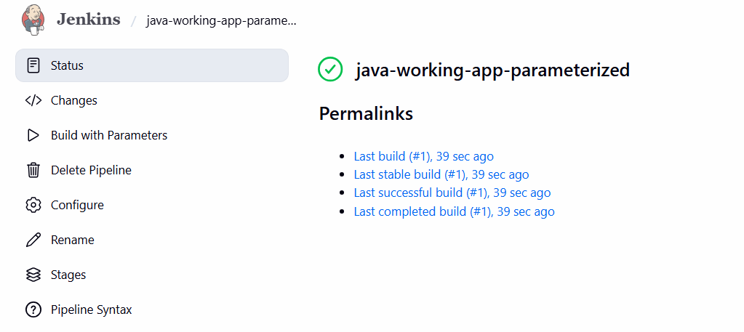
Step 5: Check Console Output
Go to: Build #1 → Console Output
mvn clean compile
...
BUILD SUCCESS
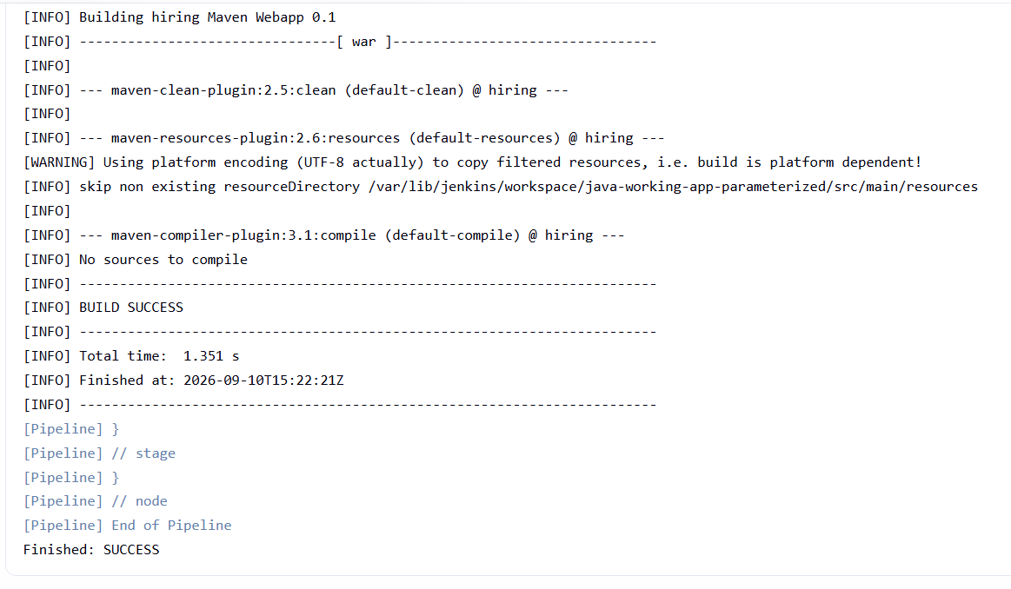

6. What are the global variables in Jenkins?
Now create another Pipeline job to understand Jenkins built-in/global variables.
Job name:
jenkins-global-variables
Create it as Pipeline.
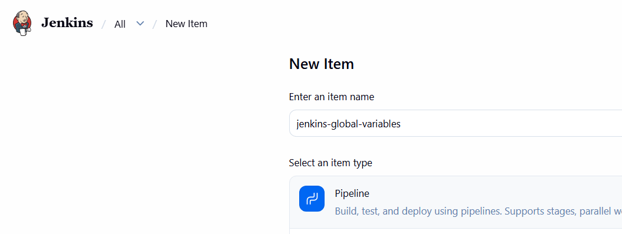
In Pipeline → Pipeline script, use:
pipeline {
agent any
stages {
stage('Git Clone') {
steps {
git branch: 'main',
url: 'https://github.com/betawins/java-Working-app.git'
}
}
stage('Show Jenkins Variables') {
steps {
echo "Job Name : ${env.JOB_NAME}"
echo "Build Number : ${env.BUILD_NUMBER}"
echo "Workspace : ${env.WORKSPACE}"
echo "Node Name : ${env.NODE_NAME}"
}
}
stage('Maven Compilation') {
steps {
sh 'mvn clean compile'
}
}
}
}
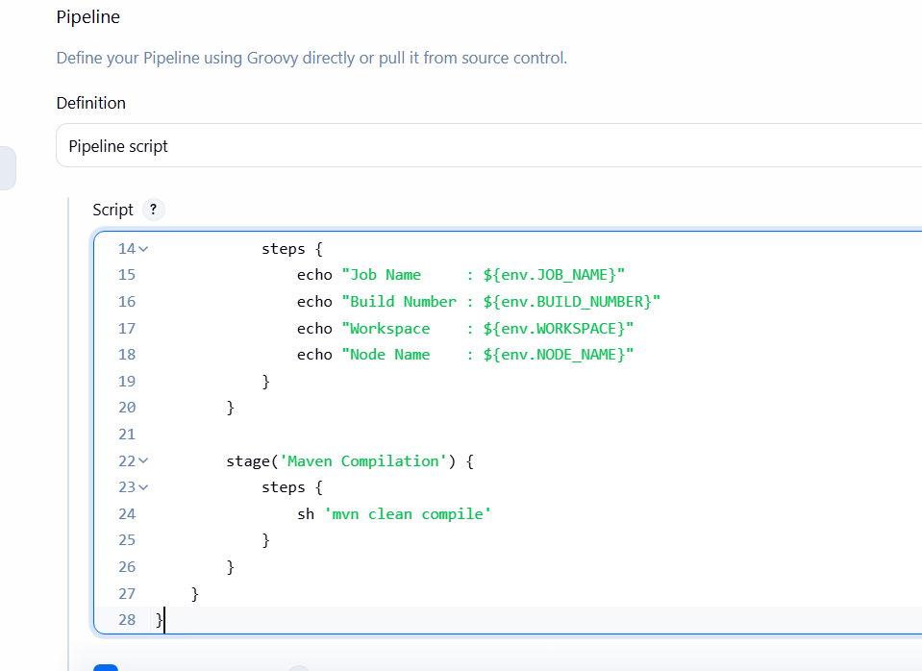
What this demonstrates
Variable | Meaning
env.JOB_NAME | Current Jenkins job name
env.BUILD_NUMBER | Current build number
env.WORKSPACE | Workspace directory used by Jenkins
env.NODE_NAME | Jenkins agent/node running the build
Save → Build Now → Console Output.
